# **Build Your DB Server and Interact With Your DB Using an App**

This lab is designed to reinforce the concept of leveraging an AWS-managed database instance for solving relational database needs.

***Amazon Relational Database Service*** (Amazon RDS) makes it easy to set up, operate, and scale a relational database in the cloud. It provides cost-efficient and resizable capacity while managing time-consuming database administration tasks, which allows you to focus on your applications and business. Amazon RDS provides you with six familiar database engines to choose from: Amazon Aurora, Oracle, Microsoft SQL Server, PostgreSQL, MySQL and MariaDB.

**Objectives**

After completing this lab, you can:

* Launch an Amazon RDS DB instance with high availability.
* Configure the DB instance to permit connections from your web server.
* Open a web application and interact with your database.

**Duration**

This lab takes approximately **45 minutes**.

**Scenario**

You start with the following infrastructure:

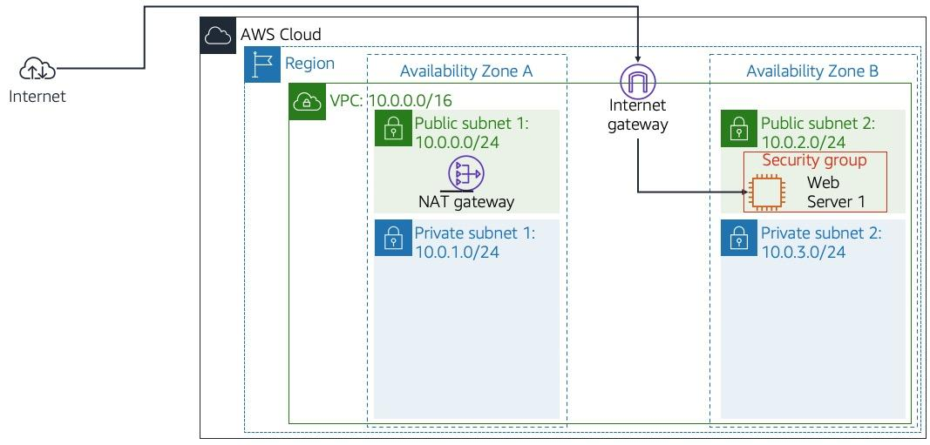

At the end of the lab, this is the infrastructure:

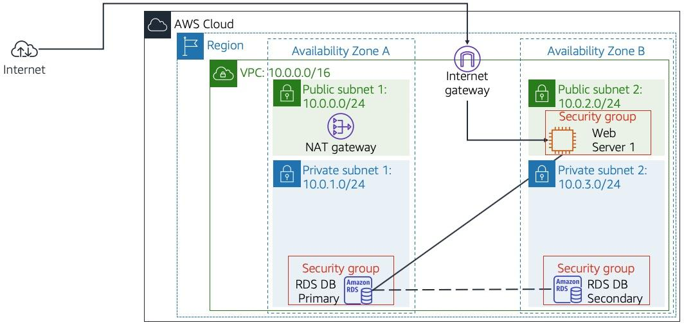

## **Accessing the AWS Management Console**

At the top of these instructions, select Start Lab to launch your lab.

1. A Start Lab panel opens displaying the lab status.
2. Wait until you see the message "**Lab status: ready**", then select the **X** to close the Start Lab panel.

Select the Details drop down menu above these instructions, and then select Show. Copy all the lab details such as **WebServer** etc and save them in a text editor.

1. The information you have saved will be referred to as *Lab Details* in the lab.

At the top of these instructions, select AWS

This will open the AWS Management Console in a new browser tab. The system will automatically log you in.

1. **Tip**: If a new browser tab does not open, there will typically be a banner or icon at the top of your browser indicating that your browser is preventing the site from opening pop-up windows. Select the banner or icon and choose "Allow pop-ups."

Arrange the AWS Management Console tab so that it displays alongside these instructions. Ideally, you will be able to see both browser tabs at the same time, to make it easier to follow the lab steps.

1. **Do not change the Region unless instructed to do so**.

## **Task 1: Create a Security Group for the RDS DB Instance**

In this task, you will create a security group to allow your web server to access your RDS DB instance. The security group will be used when you launch the database instance.

1. In the **AWS Management Console**, on the **Services** menu, click **VPC**.
2. In the left navigation pane, click **Security Groups**.
3. Click **Create security group** and then configure:
   * **Security group name:** DB Security Group
   * **Description:** Permit access from Web Security Group
   * **VPC:** *Lab VPC*
4. You will now add a rule to the security group to permit inbound database requests. The security group currently has no rules. You will add a rule to permit access from the *Web Security Group*.
5. In the **Inbound rules** section, click **Add rule**, then configure:
   * **Type:** *MySQL/Aurora (3306)*
   * **CIDR, IP, Security Group or Prefix List:** Type sg and then select *Web Security Group*.
6. This configures the Database security group to permit inbound traffic on port 3306 from any EC2 instance that is associated with the *Web Security Group*.
7. Scroll to the bottom of the screen, then click **Create security group**You will use this security group when launching the Amazon RDS database.

## **Task 2: Create a DB Subnet Group**

In this task, you will create a *DB subnet group* that is used to tell RDS which subnets can be used for the database. Each DB subnet group requires subnets in at least two Availability Zones.

1. On the **Services** menu, click **RDS**.
2. In the left navigation pane, click **Subnet groups**.  
    If the navigation pane is not visible, click the menu icon in the top-left corner.
3. Click **Create DB Subnet Group** then configure:
   * **Name:** DB Subnet Group
   * **Description:** DB Subnet Group
   * **VPC ID:** *Lab VPC*
4. In the **Add subnets** section for *Availability zones*, click the , then:
   * Select the first Availability zone
   * Select the second Availability zone
5. For **Subnets**, click the , then:
   * For the first Availability zone, select *10.0.1.0/24*
   * For the second Availability zone, select *10.0.3.0/24*
6. Click **Create**This adds Private Subnet 1 (10.0.1.0/24) and Private Subnet 2 (10.0.3.0/24). You will use this DB subnet group when creating the database in the next task.

## **Task 3: Create an Amazon RDS DB Instance**

In this task, you will configure and launch a Multi-AZ Amazon RDS for MySQL database instance.

Amazon RDS ***Multi-AZ*** deployments provide enhanced availability and durability for Database (DB) instances, making them a natural fit for production database workloads. When you provision a Multi-AZ DB instance, Amazon RDS automatically creates a primary DB instance and synchronously replicates the data to a standby instance in a different Availability Zone (AZ).

1. In the left navigation pane, click **Databases**.
2. Click **Create database** If you see **Switch to the new database creation flow** at the top of the screen, please click it.
3. Select **MySQL**.
4. Under **Settings**, configure:
   * **DB instance identifier:** lab-db
   * **Master username:** main
   * **Master password:** lab-password
   * **Confirm password:** lab-password
5. Under **DB instance size**, configure:
   * Select **Burstable classes (includes t classes)**.

Select *db.t3.micro*.

* + **Note**: If the *db.t3.micro* instance is not available in the Availability Zone, choose *db.t2.micro* instead.

1. Under **Storage**, configure:
   * Select *General Purpose (SSD)* under **Storage type**.
2. Under **Connectivity**, configure:
   * **Virtual Private Cloud (VPC):** *Lab VPC*
3. Expand **Additional connectivity configuration**.
4. For **Existing VPC security groups:**
   * Select **DB Security Group** to highlight it in blue
   * De-select *default*
5. Expand **Additional configuration**, then configure:
   * **Initial database name:** lab
   * Uncheck **Enable automatic backups**.
6. This will turn off backups, which is not normally recommended, but will make the database deploy faster for this lab.
7. Scroll to the bottom of the screen, then click **Create database**Your database will now be launched.
8. Click **lab-db** (click the link itself).  
   You will now need to wait **approximately 4 minutes** for the database to be available. The deployment process is deploying a database in two different Availability zones.  
    While you are waiting, you might want to review the [Amazon RDS FAQs](https://aws.amazon.com/rds/faqs/) or grab a cup of coffee.
9. Wait until **Info** changes to **Modifying** or **Available**.
10. Scroll down to the **Connectivity** section and copy the **Endpoint** field.  
    It will look similar to: *lab-db.cggq8lhnxvnv.us-west-2.rds.amazonaws.com*
11. Paste the Endpoint value into a text editor. You will use it later in the lab.

## **Task 4: Interact with Your Database**

In this task, you will open a web application running on your web server and configure it to use the database.

1. Copy the **WebServer** IP address from the *Lab Details.txt* file, or by selecting on the Details drop down menu above these instructions, and then select Show.
2. Open a new web browser tab, paste the *WebServer* IP address and press Enter.  
   The web application will be displayed, showing information about the EC2 instance.
3. Click the **RDS** link at the top of the page.  
   You will now configure the application to connect to your database.
4. Configure the following settings:
   * **Endpoint:** Paste the Endpoint you copied to a text editor earlier
   * **Database:** lab
   * **Username:** main
   * **Password:** lab-password
   * Click **Submit**
5. A message will appear explaining that the application is running a command to copy information to the database. After a few seconds the application will display an **Address Book**.  
   The Address Book application is using the RDS database to store information.
6. Test the web application by adding, editing and removing contacts.  
   The data is being persisted to the database and is automatically replicating to the second Availability Zone.

## **Lab Complete**

Congratulations! You have completed the lab.

​

Select End Lab at the top of this page and then select **Yes** to confirm that you want to end the lab.

1. A panel will appear, indicating that "DELETE has been initiated... You may close this message box now."

Select the **X** in the top right corner to close the panel.

​